1. Machine Learning, Supervised Learning, Classification
2. 399Rows and 25 columns
3. This is Nominal data
4. Logistics regression

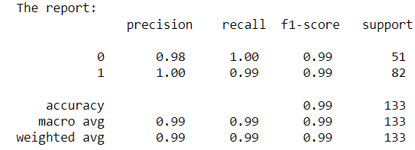

roc_auc_score=1.0

Decision Tree

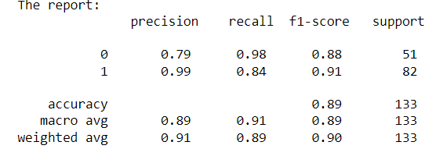

roc_auc_score= 0.910927

Random Forrest

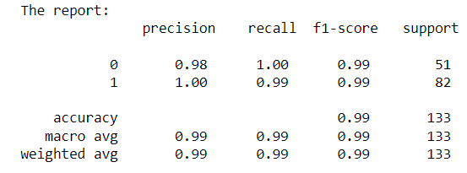

roc_auc_score= 1.0

KNN

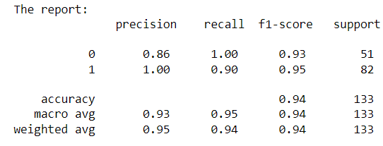

roc_auc_score= 0.999282

SVM

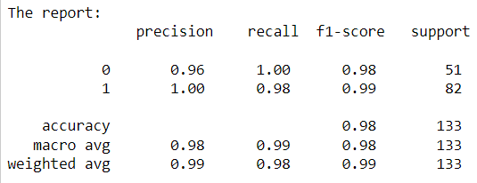

roc_auc_score=1.0